Preface

This Guide explains how to use the functionality of Trade Innovation Maker Checker application to maintain and authorise Static and System Tailoring data. It assumes that you are familiar with the basic principles of Trade Finance, and with web browsers.

# Maker Checker in Trade Innovation

This chapter covers the functionality provided by Maker Checker in Trade Innovation.

## Overview

The Maker Checker application provides the bank with the ability to enter data into the bank’s production system in a more secure way. It allows each item to be checked and reviewed by one or users before it is applied for live use.

The data entered via the Maker Checker application is separated into the follow areas;

* Zone level data – this is common data that applies to any customer or banking business defined in the zone covering such items as account officers, calendars, programme sub-types, default country days, SLA types, tracers and bank wide default charge and interest schedules.
* Customer level data – this applies to data associated with the bank’s customers covering
* Customer specific static data such as customer input, TI customer details, addresses, standing settlement instructions, customer groups, customer accounts and correspondents.
* Customer specific tailoring data including charge schedules, interest schedules, customer expiry grace days, finance default mappings, customer billing details, programmes and reference blocks.
* Branch level data –this is data applicable to a specific part of the bank’s business such as Clearing System IDs, internal accounts, nostros, default nostros,TI SWIFT details and Insurance.

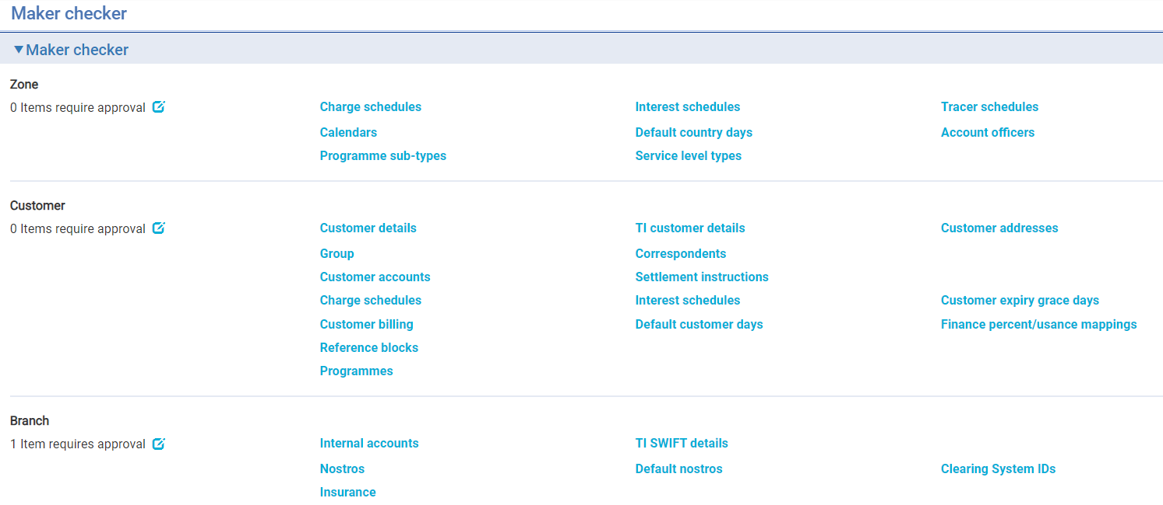

The table shows the menu options in the Maker Checker application:

| Menu Bar Option | | Sub-Option | What it Does |
| --- | --- | --- | --- |
| Zone | Items require approval | | Shows the number of items that requires approval and enables you to approve these items. |
|  | Items require further input | | Shows the number of items that requires further input and enables you to maintain these items. |
|  | Charge schedules | | Allows you to define default, branch level and charge group charge schedules. |
|  | Interest schedules | | Allows you to define default level and branch level interest schedules. |
|  | Tracer schedules | | Allows you to define tracer schedules against tracer events |
|  | Calendars | | Allows you to enter local branch, country and currency calendars. |
|  | Default country days | | Allows you to specify the default days for transit interest and for pre-debit notifications at country and country /branch level |
|  | Account officers | | Allows you to add, update, or delete details of account officers. |
|  | Programme sub-types | | Allows you to set up a buyer or seller centric finance or pool based factoring programme sub-type. |
|  | Service level types | | Allows you to define Service level types and assign the relevant customers, groups and customer types that apply to that service level. |
| Customer | Items require approval | | Shows the number of items that requires approval and enables you to approve these items. |
|  | Items require further input | | Shows the number of items that requires further input and enables you to maintain these items. |
|  | Customer details | | Allows you to maintain customer information. |
|  | TI customer details | | Allows you to maintain TI specific customer information. |
|  | Customer addresses | | Allows you to maintain customer addresses, including Structured name and address, and address instructions |
|  | Group | | Allows you to maintain the customer groups that customers belong to. |
|  | Correspondents | | Allows you to maintain the correspondent banks your bank uses. |
|  | Customer accounts | | Allows you to maintain accounts for a customer. |
|  | Settlement instructions | | Allows you to define standing settlement instructions for a customer |
|  | Charge schedules | | Allows specific charge schedules to be defined for a customer. |
|  | Interest schedules | | Allows specific interest schedules to be defined for a customer. |
|  | Customer expiry grace days | | Allows transaction domestic and overseas expiry grace days to be set by customer. |
|  | Customer billing | | Allows you to define how charges are to be billed/invoiced for a customer. |
|  | Default customer days | | Allows you to specify the default days for transit interest and for pre-debit notification. |
|  | Finance percent/usuance mappings | | Allows you to define by customer and product type the default percentage to be applied to the amount of a transaction to determine the finance amount together with the default term. |
|  | Reference blocks | | Allows you to allocate a block of product reference numbers to a particular customer. |
|  | Programmes | | Allows you to set up either buyer or seller centric programmes for your customers and their counterparties. |
|  |  | |  |
| Branch | Items require approval | | Shows the number of items that requires approval and enables you to approve these items. |
|  | Items require further input | | Shows the number of items that requires further input and enables you to maintain these items. |
|  | Internal accounts | | Used by your bank as contra accounts used for recording liability, accruals and suspense accounts. |
|  | TI SWIFT details | | Allows your bank to hold authentication, closed and blocked status information for any SWIFT BIC by main banking entity, to ensure the SWIFT BIC is valid for use within that part of the bank’s business.. |
|  | Nostros | | Allows you to define details of the bank’s nostros. |
|  | Default nostros | | Allows you to define default nostros for individual branches when settling funds |
|  | Clearing System IDs | | Allows you to define details of the clearing systems your bank uses. |
|  | Insurance | | Allows the user to record the Insurance policy details that can be used at the transaction level. |

## Access to Maker Checker Maintenance Functions

The security capabilities assigned to a user determine which maintenance functions they can perform.

When Maker Checker is ‘off’, the user can use the standard functions such as those in Static Data Maintenance and System Tailoring.

When Maker Checker is ‘on’, the user can use the equivalent functions in Maker Checker and the standard functions become view only.

## Maker Checker and the Configuration Management Tool

Maker Checker works hand in hand with the Configuration Management Tool (CMT) in the following way:

* CMT is used to configure Products in a Golden Source system and once Acceptance testing is completed the changes can be promoted to the bank’s live system.
* Maker Checker on the other hand, is used to maintain and authorise Zone, Customer, and Branch related data that can only updated in the production system.

# Enabling Maker Checker and Defining the Number of Approvers

Maker Checker is enabled by setting the relevant Zone level system options from ***System Tailoring|General system definition|Zone options***.

The following system tailoring options enable Maker Checker and define the number of approvers required:

* MakerCheckerRequired – if set to Yes, it enables the Maker Checker application to those users to whom it is assigned.
* MakerCheckerNoOfAuthorisersZone – defines the number of users needed to authorise a zone level tailoring item before it can be applied to the system. If not set, the system defaults to 1.
* MakerCheckerNoOfAuthorisersCustomer - defines the number of users needed to authorise a customer level tailoring item before it can be applied to the system. If not set, the system defaults to 1.
* MakerCheckerNoOfAuthorisersBranch - defines the number of users needed to authorise a branch level tailoring item before it can be applied to the system. If not set, the system defaults to 1.

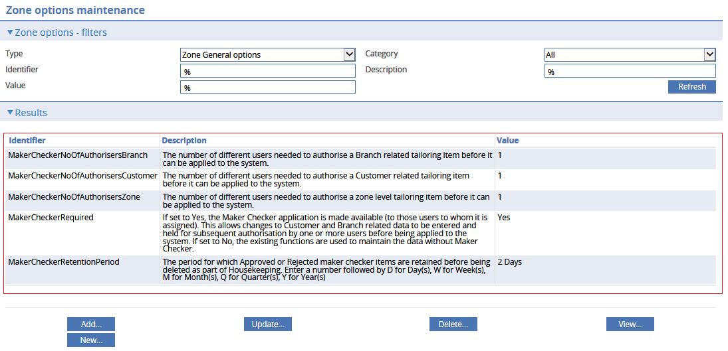

An additional system option is used to define the period of time for which Approved and Rejected items should be retained for enquiry purposes. Once the retention period is past the items will be deleted as part of the Housekeeping task.

* MakerCheckerRetentionPeriod - The period for which Approved or Rejected maker checker items are retained before being deleted as part of Housekeeping. Enter a number followed by D for Day(s), W for Week(s), M for Month(s), Q for Quarter(s), Y for Year(s)

# Using Maker Checker

## Overall Workflow

The following diagram describes the overall flow for Maker Checker.

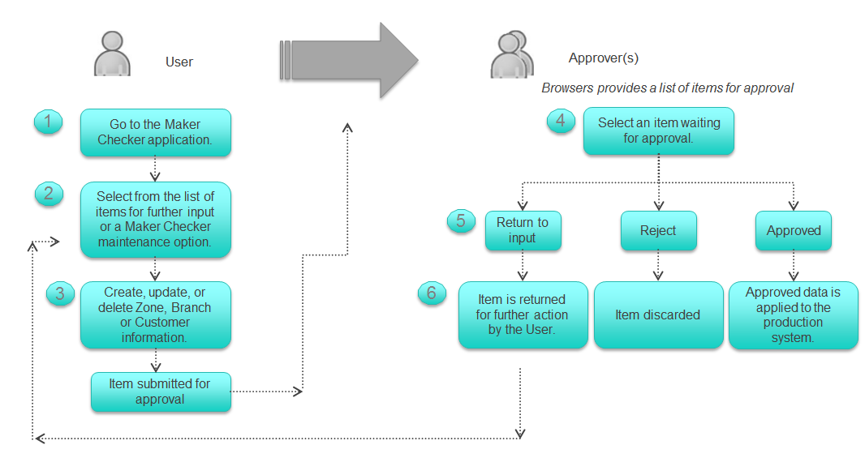

## Accessing Functions that Require Maker Checker

When you select the **Maker Checker** application from the Trade Innovation Applications List the following menu is shown allowing you to select items at Zone, Customer, and Branch level for maintenance and subsequent approval.

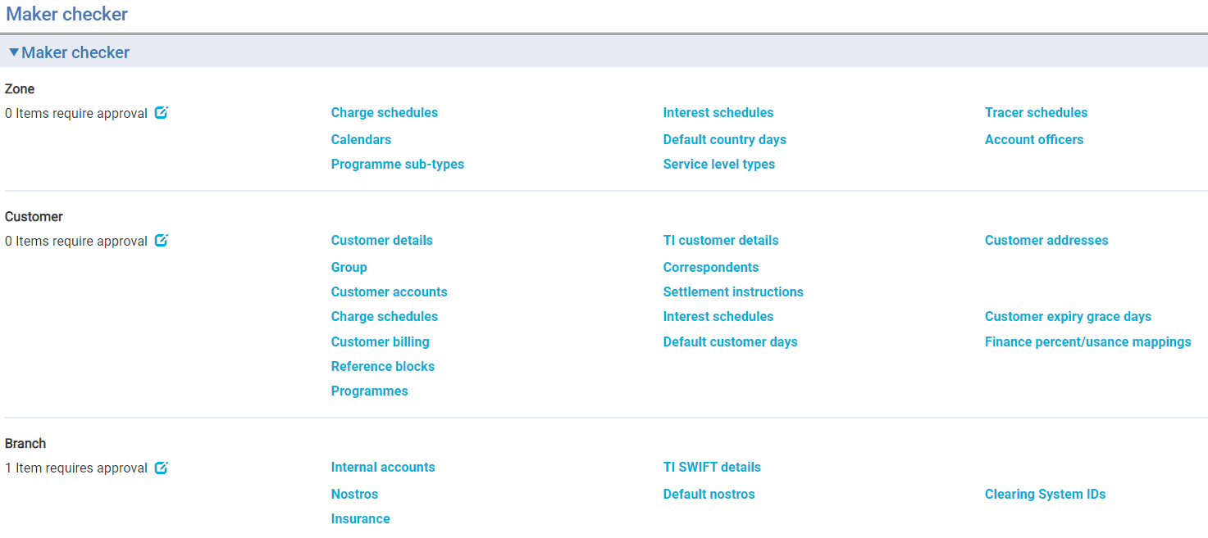

## Amending Data in Maker Checker

The Maker Checker application functions are used to create, update, delete, copy and view items.

These actions are performed in exactly the same way as in the standard functions.

For a full description of the functions, see the System Tailoring User Guide – Trade Innovation and Static Data Maintenance User Guide – Trade Innovation.

1. If your bank has the Maker Checker option enabled then any maintenance of the items shown in the Maker Checker menus can only be carried out in the Maker Checker application. You can still view the items either in the System Tailoring or the Static Data application but you cannot maintain them there.

In general, the standard browsers used in Static data and System Tailoring are also used in Maker Checker. However, where data can be defined both at the zone level and customer level, such as charge schedules, then there are different browsers that show only the appropriate data for that level.

### Charge Schedule Browsers

When entering charges schedules the following browsers are used:

* Zone Level – this browser displays schedules for Default, Branch and Charge groups.

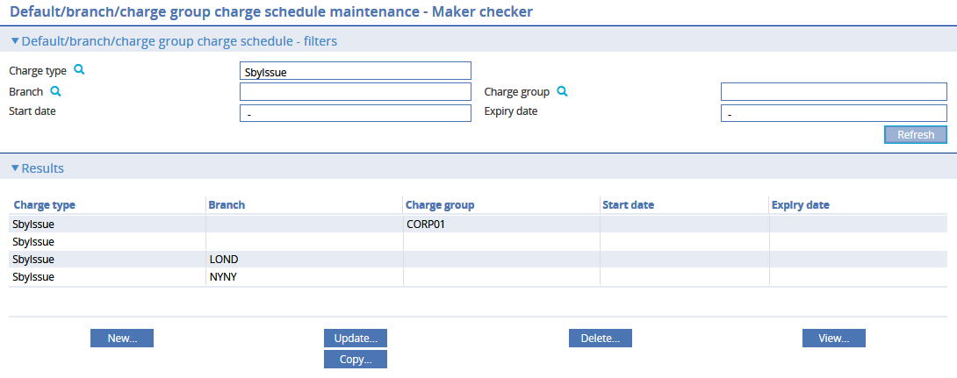

* Customer level –this browser displays schedules for Customer, Customer/Branch, Programmes and Programmes/Branch.

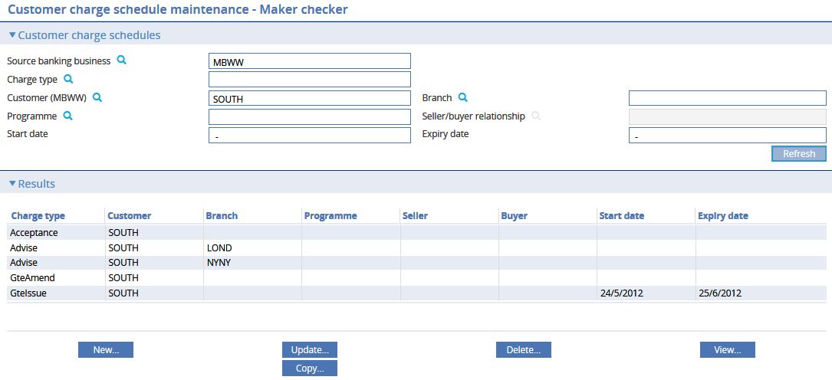

### Interest Schedule Browsers

When entering interest schedules the following browsers are used:

* Zone Level – this browser displays Default schedules and branch level schedules.

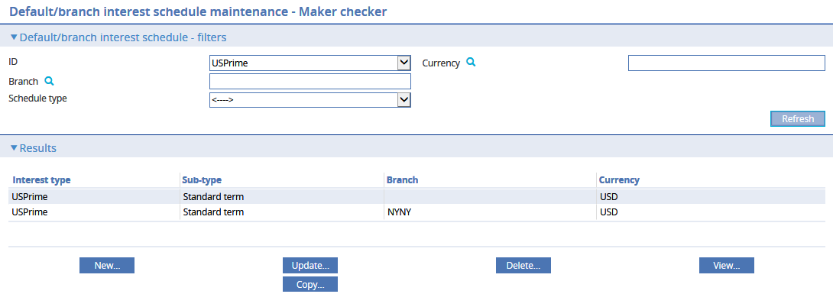

* Customer level –this browser displays schedules for Customer, Customer/Branch, Programmes and Programmes/Branch

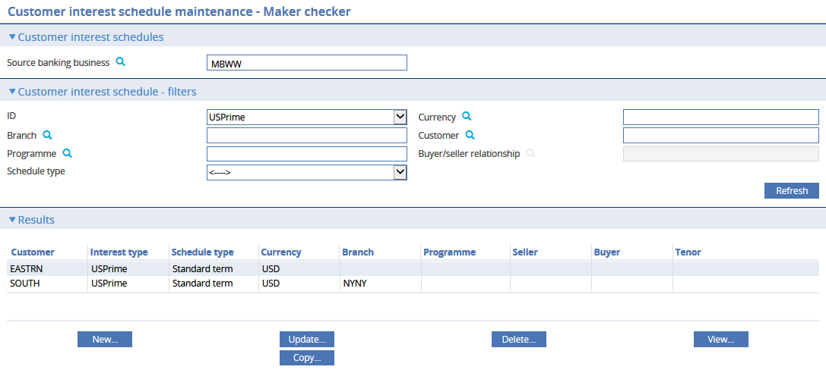

### Default Country Days

When entering default days the following browsers are used:

* Zone Level – this browser displays Default transit and pre-debit notification days for Country and Country/Branch.

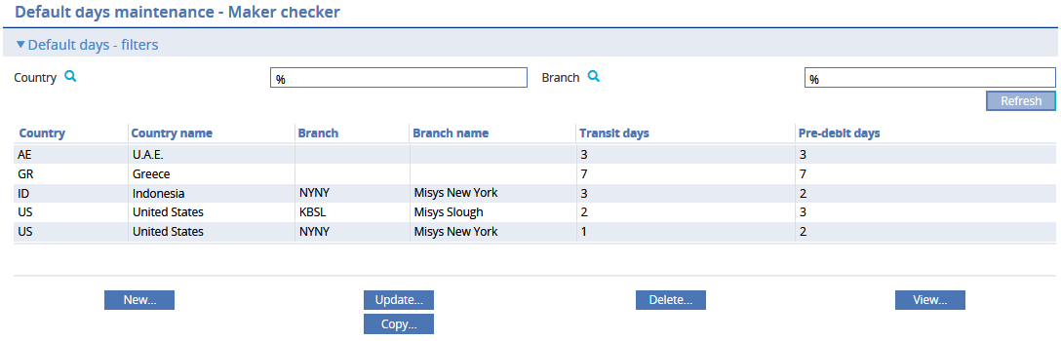

* Customer level – this browser displays Default transit and pre-debit notification days for specific customers.

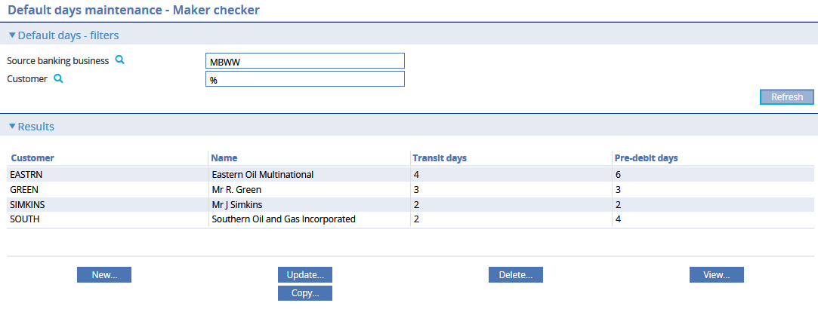

## Maker Checker Maintenance - Example

The following example illustrates the typical workflow for maker checker maintenance.

Customer charge schedules are initially selected for customer SOUTH:

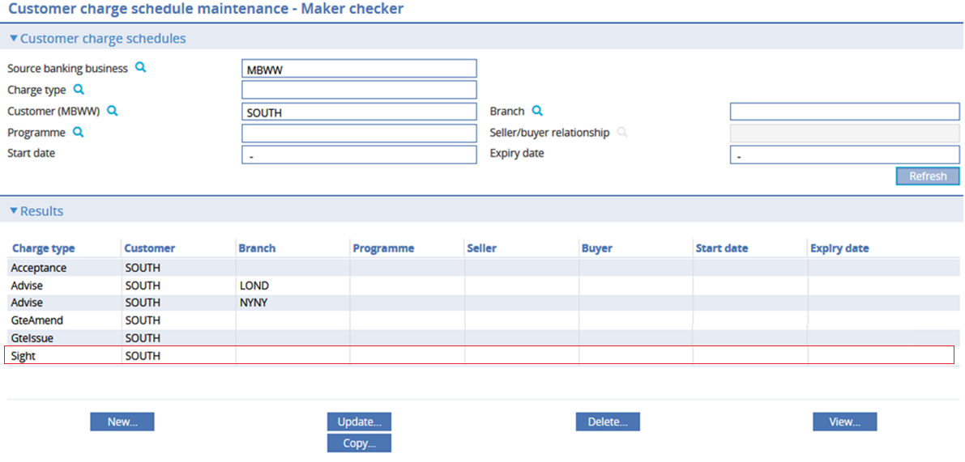

The Sight issuance charge is selected for update and the minimum charge is changed from 75 USD to 100 USD.

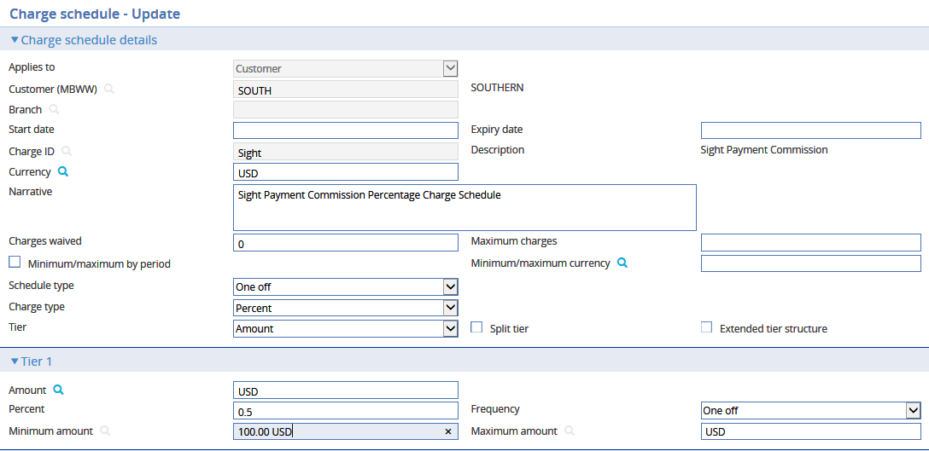

The View changes... button allows you to see the changes that have been made:

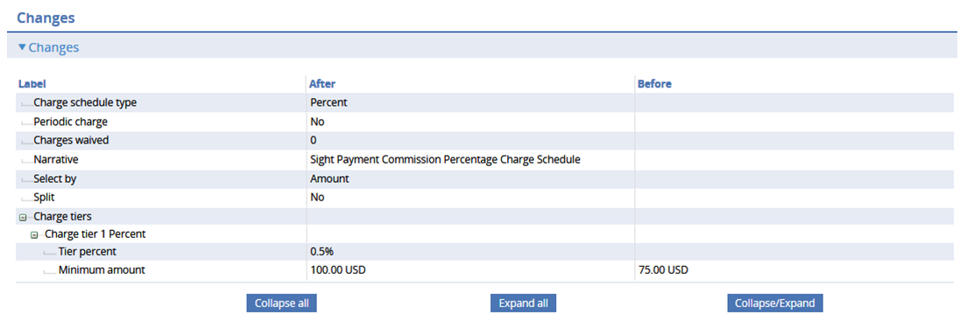

#### Notification

When your changes are submitted, you will receive a notification.

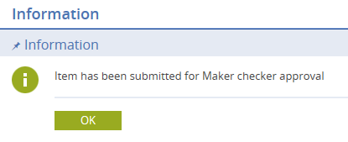

You will not be allowed to make changes to items after they are submitted. If you select a submitted item, the system will prompt you with the status message “Item is Awaiting approval and may not be modified”. Similarly, the system will not allow you add an item with the same details where there is a New item awaiting authorisation.

If any changes are required the approver must return the item to you for more changes.

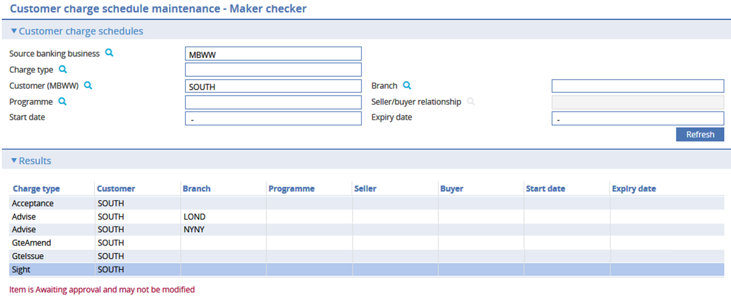

#### Authorising Changes to Data

Once any maintenance is completed the items are added to the **Items require approval** queue for another user to approve

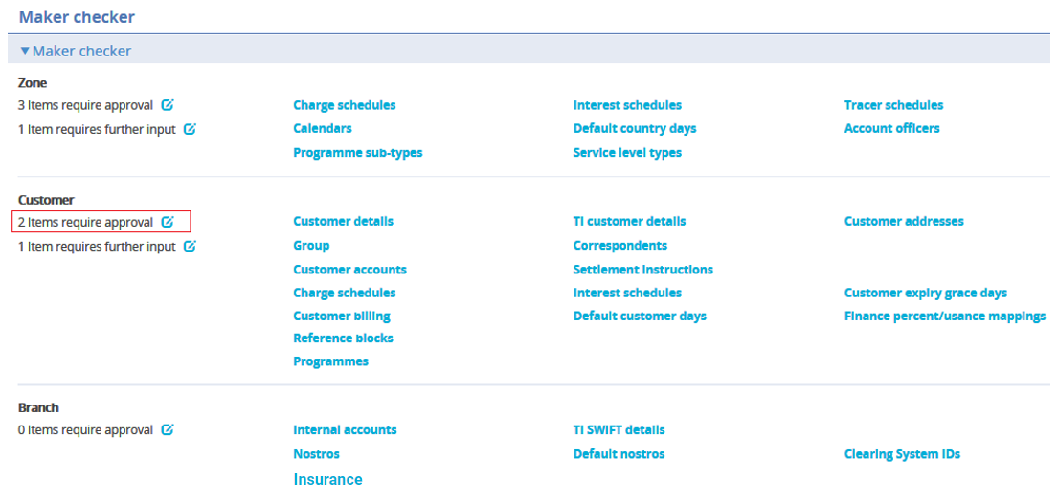

Click  to open the screen for items that require your approval. Select **Refresh** to display the items.

Depending on whether the data is Zone, Customer or Branch a different authorisation browser is shown but each browser behaves in a similar same way.

The following filters are available:

* Item type – allows a specific maintenance type to be selected
* Identifier - allows a specific item to be found by name
* Mode – allows New, Update or Delete to be selected
* Status – allows Awaiting approval, Awaiting input, Approved or Rejected to be selected

Zone

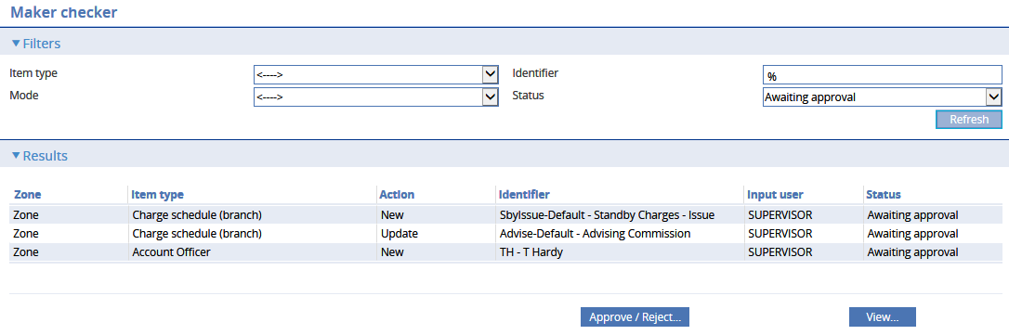

Branch

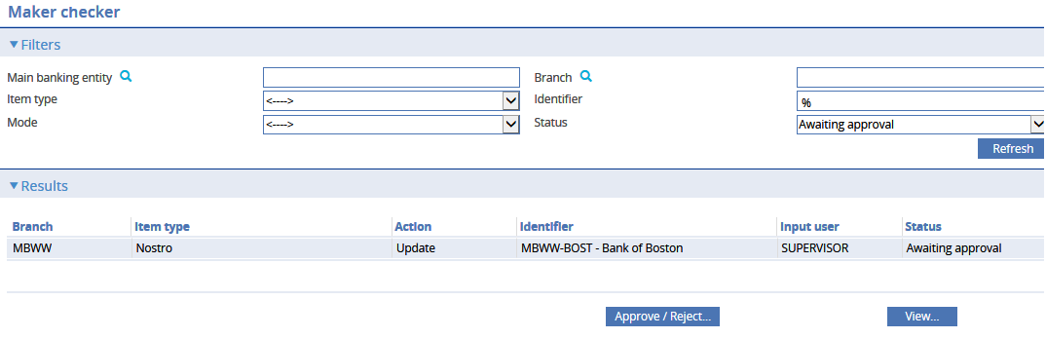

Customer

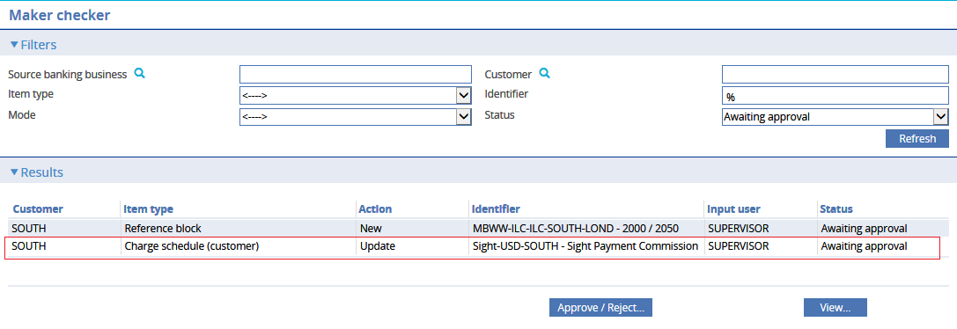

Select an item to approve and click **Approve / Reject**.

If you are an Approver, you can review and either **Approve** the change, **Reject** the change or **Return to input**

The View ‘Before/After maintenance’ dropdown allows you to see the details in the screen fields.

The **View changes...** button allows you to see the before and after details as described above.

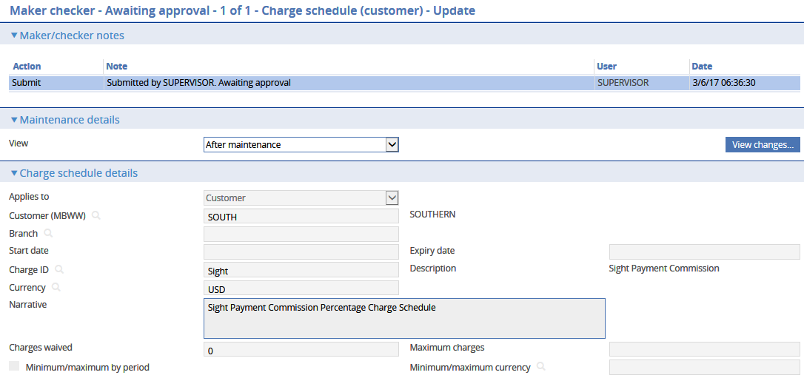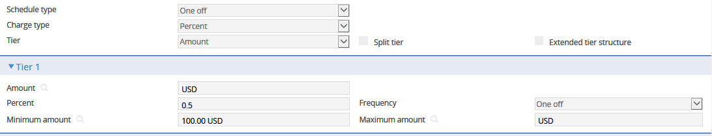

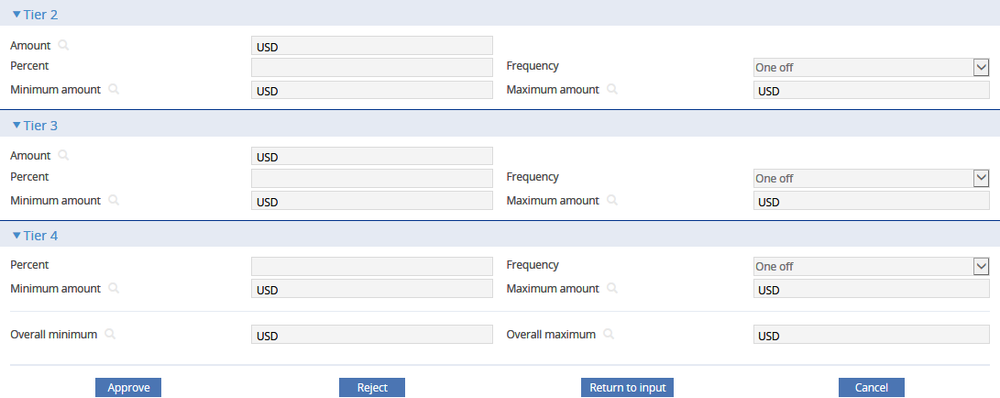

### Approving an Item

If you are the final authoriser and you select **Approve** the system processes the details and the maker checker is ‘Approved’ and is no longer shown in the Awaiting approval list. The details of the approved item are journalled together with the authorisation history.

If more than 1 approver is required the item remains awaiting approval and the system displays the user who made the changes and details of all previous authorisers

For example:

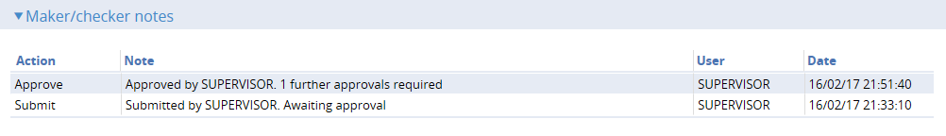

### Return to Input

If the item requires correction, then when you click **Return to input** the system displays the following screen: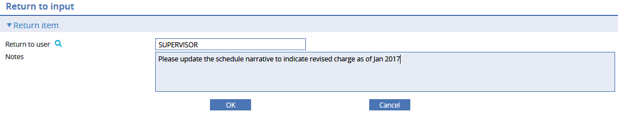

This allows you to assign the item to another user together with some notes to indicate the corrections that are required. The system will then display the item in the **Items require further input** list.

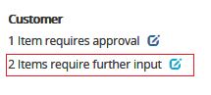

This then allows the item to be selected for correction:

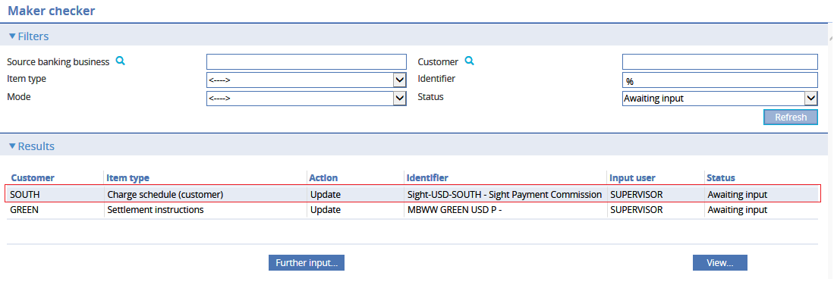

The user making the correction can see the relevant notes:

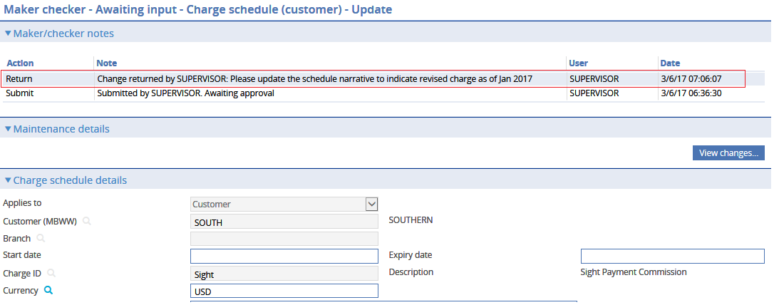

### Rejecting an Item

When you click **Reject** the system will display the following screen:

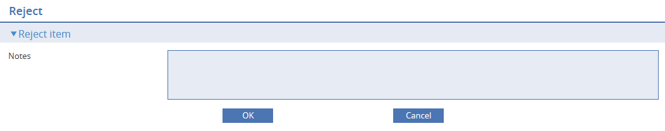

This allows you to enter the reason for rejecting the changes. The item is flagged as ‘Rejected’ and the details of the rejected item are journalled together with the authorisation history.

### Viewing Completed Items

This authorisation browser can be used to view previously Approved or Rejected items by selecting the relevant dropdown filter.

### Housekeeping

Any approved or rejected item is deleted as part of the Batch Housekeeping function once he retention period for the item has been passed.